**Apache Airflow - Assignment**

**Step 1**: Install docker exe from google, choose Download for Windows-AMD64

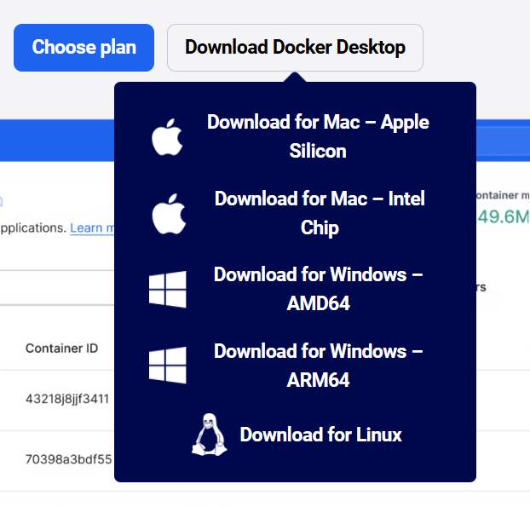

**Step 2**: Double click on the exe file you downloaded and after the process gets completed restart you system.

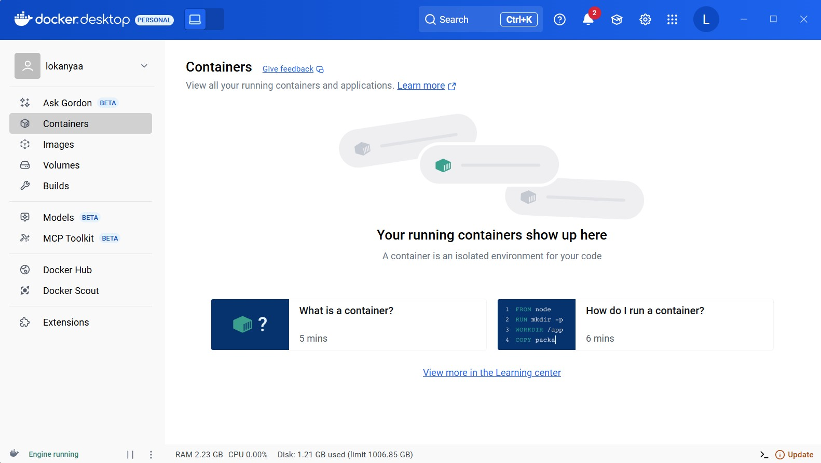

**Step 3**: Open this location “C:\Users\user name\materials” and paste the ‘docker-compose.yaml’ file in it.

**Step 4**: Now right click on the file and open with vs code(open a folder), in the vs code folder create ‘.env’ file and paste the below command .

AIRFLOW_IMAGE_NAME=apache/airflow:2.4.2

AIRFLOW_UID=50000

**Step 5**: Again in vs code on the same location open a new terminal and run the below command.

docker-compose up -d

**Step 6**: Open chrome and type ‘localhost:8080’ ,Docker UI window will open then you have to enter the password and username and login .’

**Step 7**: Now the final Docker workpage gets opened.

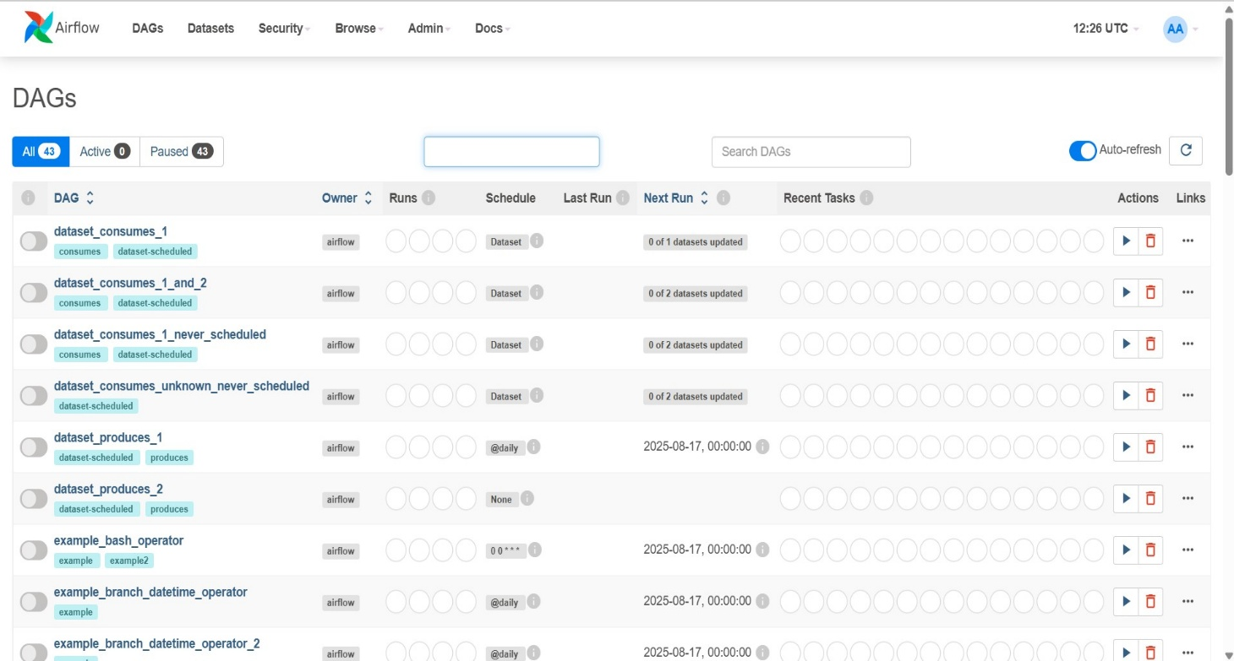

Docker page after setup done in chrome.

